MANUAL - INVENTORY
① STOCK AVAILABLE
➡️ In this module, you will be notified of the number of items that are still in stock, the number of items that need to be reordered, and the number of items that are out of stock.
➡️It also provides details on each item’s beginning balance, available stock, purchases, and issuances throughout the year, allowing you to perform stock balancing.
Navigate the Page to Stock Available
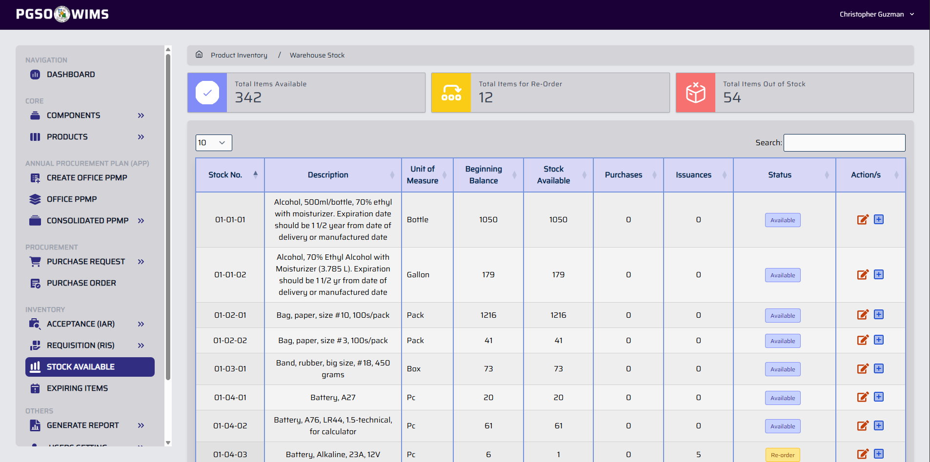

➤ Set or Update Item Inventory Reorder Level / Threshold
Step 1. On the Item table, click on the Edit Icon button to display a form.
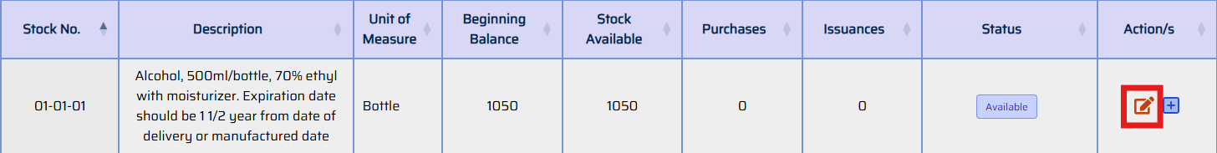
Step 2. Edit the number of reorder level of the particular.
Step 3. Click Confirm button to proceed.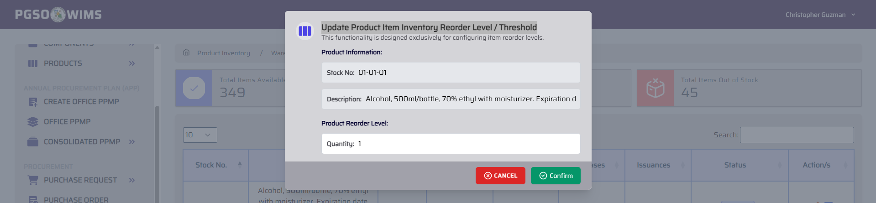

➤ Set or Update Beginning Balance of an Item
➡️ This feature is designed to support data migration and buildup during the transition from the legacy system to the new system.
Step 1. On the Item table, click on the Add Icon button to display a form.
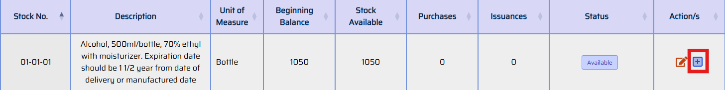
Step 2. Complete the input fields.
Input Fields:
Quantity – Beginning balance
Remarks – Transaction description (e.g., “Beginning Balance”)
Date – Set to January 1
Step 3. Click Confirm button to proceed.
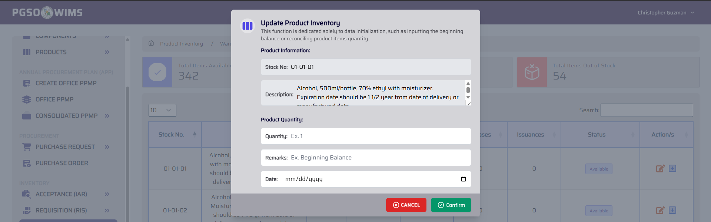

② EXPIRING ITEMS
➡️ This module notifies you of items in the inventory that are about to expire and those that are already expired.

Navigate the Page to Expiring Items 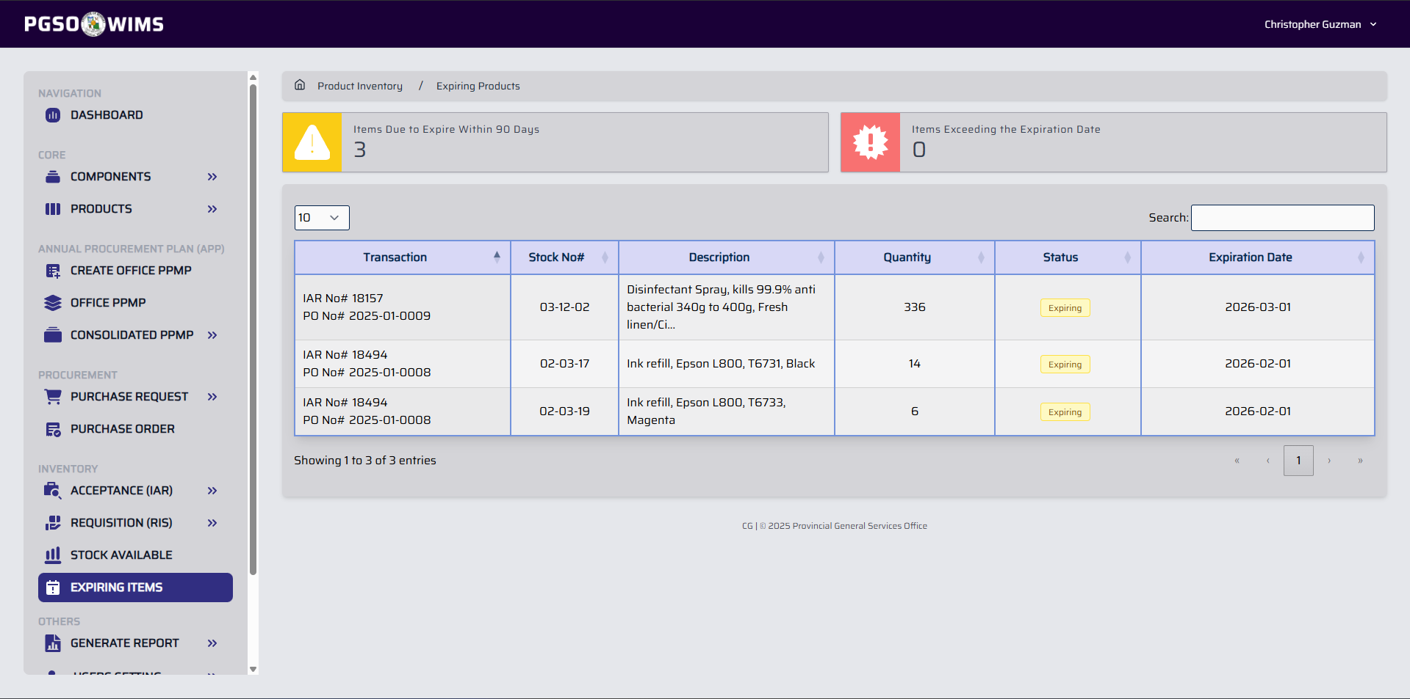

③ INSPECTION AND ACCEPTANCE REPORT
➡️ IAR transactions from the Delivery Unit are imported and recorded in the system.
Navigate the Page to Acceptance (IAR) → Receiving 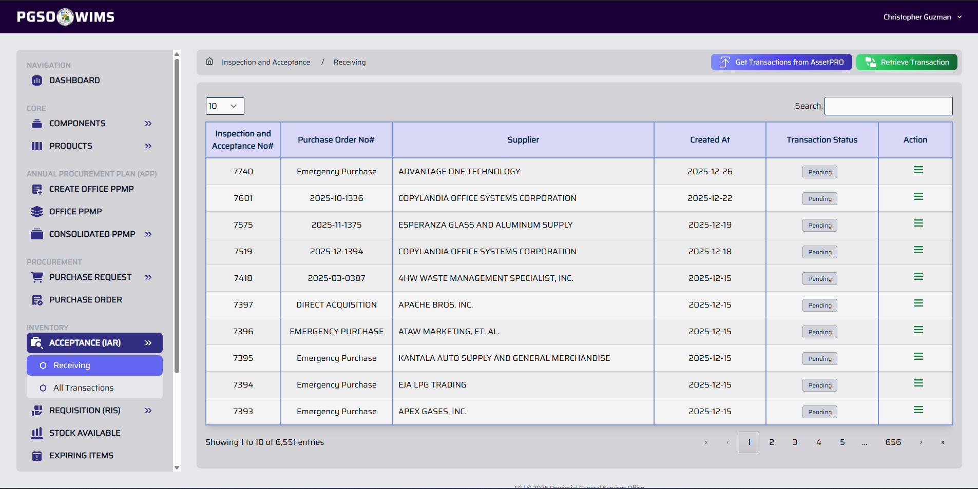

➤ Get Transactions from AssetPro
Step 1. On the Receiving Section, click on the Get Transactions from AssetPRO button.
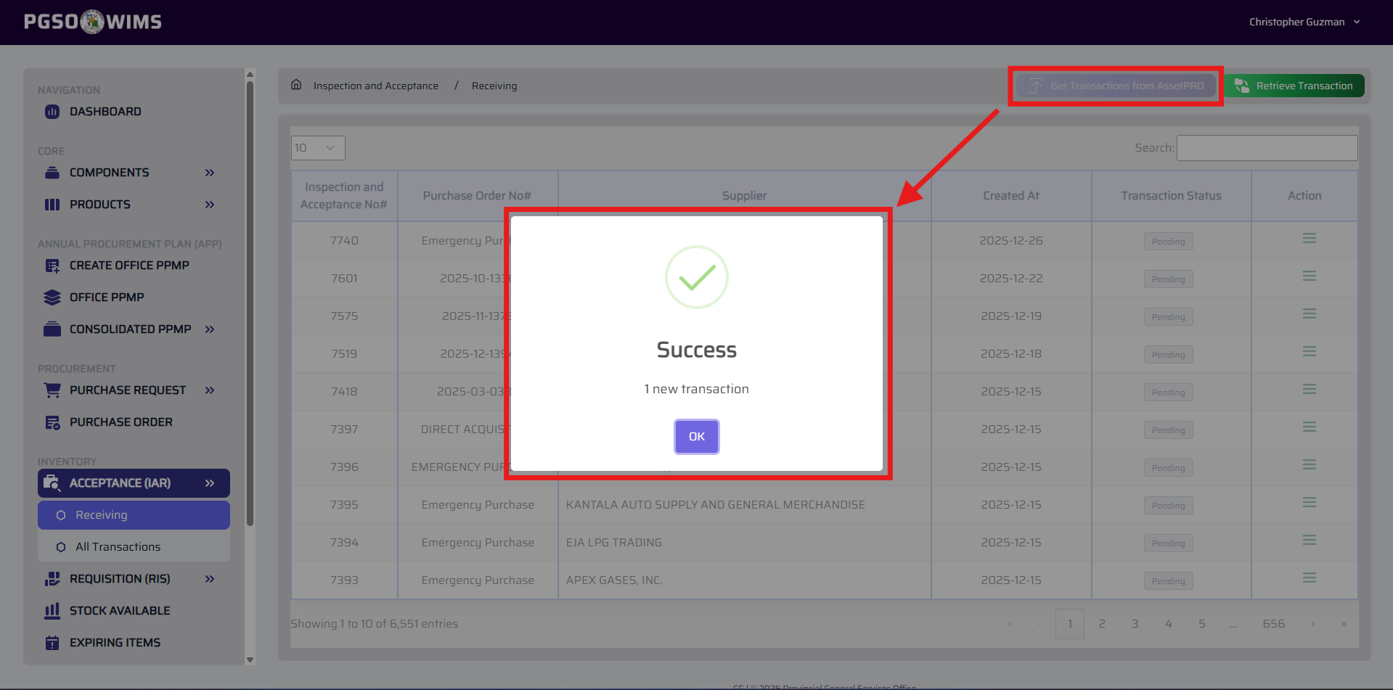
This retrieves all new transactions but is case-sensitive and ignores transactions with IDs lower than the latest ID. Use the alternate feature instead (refer to the Retrieve IAR Transaction Feature) if a transaction is not present on the list.

➤ Retrieve IAR Transaction
Step 1. On the Receiving Section, click on the Retrieve Transaction button.
Step 2. Complete the input fields.
Input Fields:
IAR Code – The issued code for the IAR
Calendar Year – The year the IAR transaction was created
Step 3. Click Confirm button to proceed.
Step 4. Verify transaction on the IAR Transaction Table.

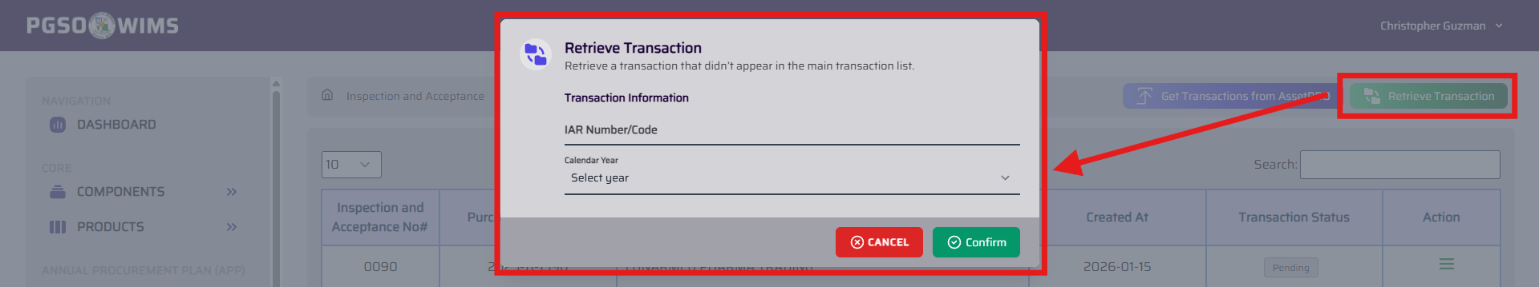

➤ View IAR Transaction
Step 1. On the IAR Transaction Table, click on the View Icon button.
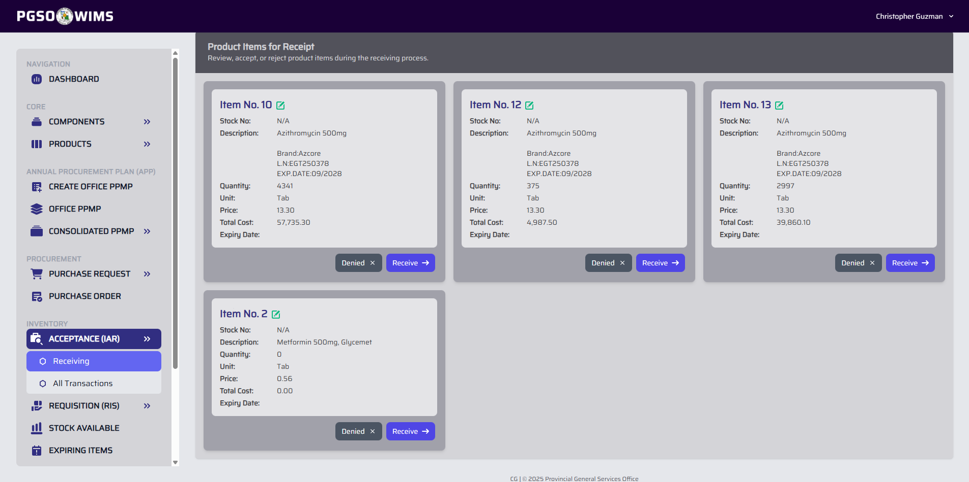

➤ Receive All Particulars within the IAR Transaction
Step 1. On a specific IAR Transaction, click on the Accept All button.
Step 2. Set the Date Received of the transaction.
Step 3. Click Confirm button to proceed.
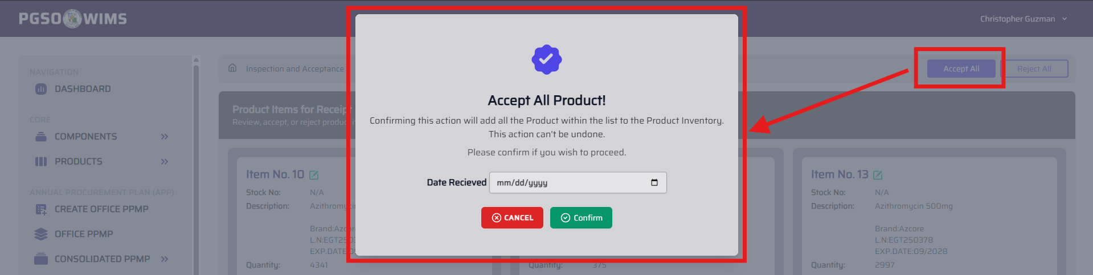
All particulars within the IAR transaction will be accepted. However, there may be instances where a particular remains unaccepted due to not meeting the required criteria. This can be resolved by updating the particular.

➤ Reject All Particulars within the IAR Transaction
Step 1. On a specific IAR Transaction, click on the Reject All button.
Step 3. Click Confirm button to proceed.
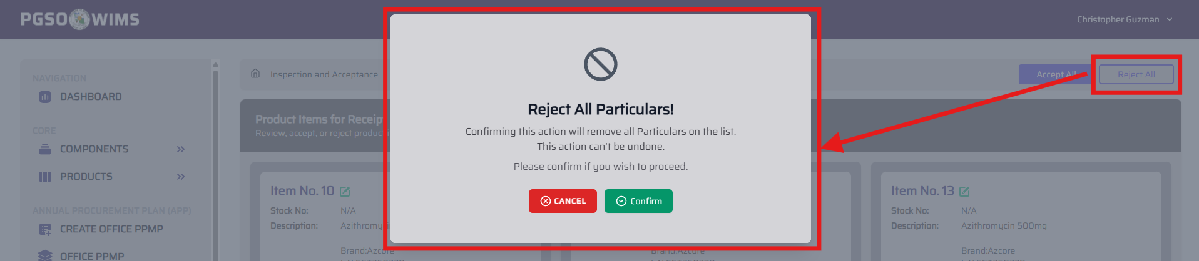
All particulars within the IAR Transaction will be rejected.
➤ Update Particular within the IAR Transaction
Step 1. On a specific IAR Transaction, click on the Edit Icon button on a specific IAR Particular (beside the Item No. Label).
Step 2. Edit the details on the form.
Input Fields
Stock Number – Complete item code
Expiration Date – Available only for items classified as Limited-life products
Description – Additional description or remarks
Unit of Measure – Must match the unit defined in the Product Information
Qty – Adjust the quantity if the unit of measure is changed
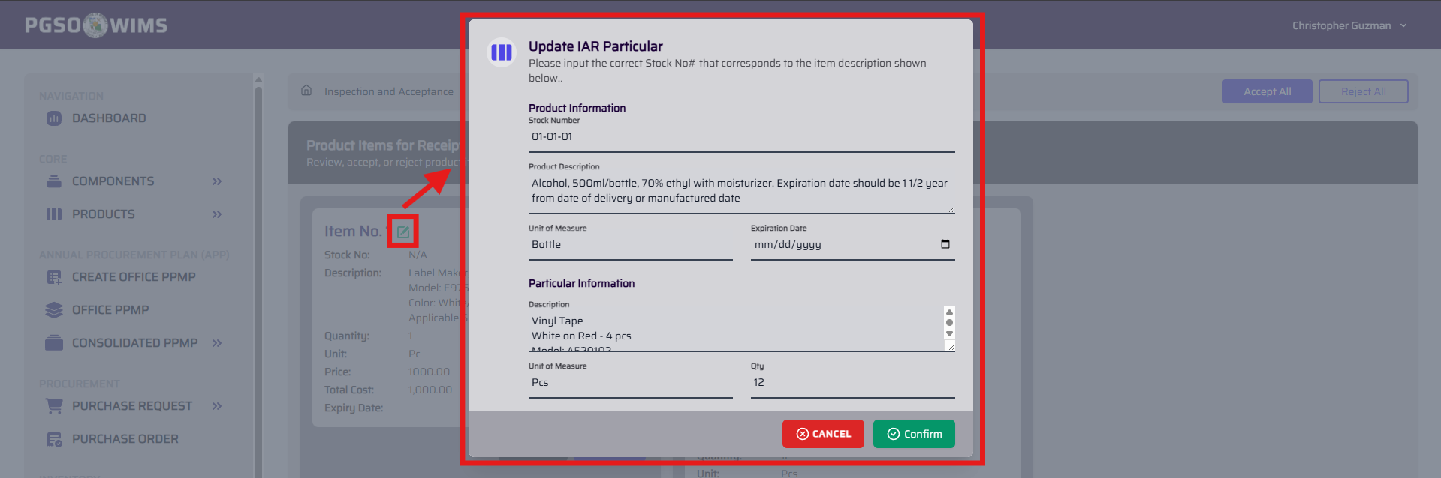
Refer to the Product Information to match the IAR Particular information accurately.
Step 3. Click Confirm button to proceed.
➤ Receive Particular within the IAR Transaction
Step 1. On a specific IAR Transaction, click on the Receive button.
Step 2. Set the Date Received of the transaction.
Step 3. Click Confirm button to proceed.
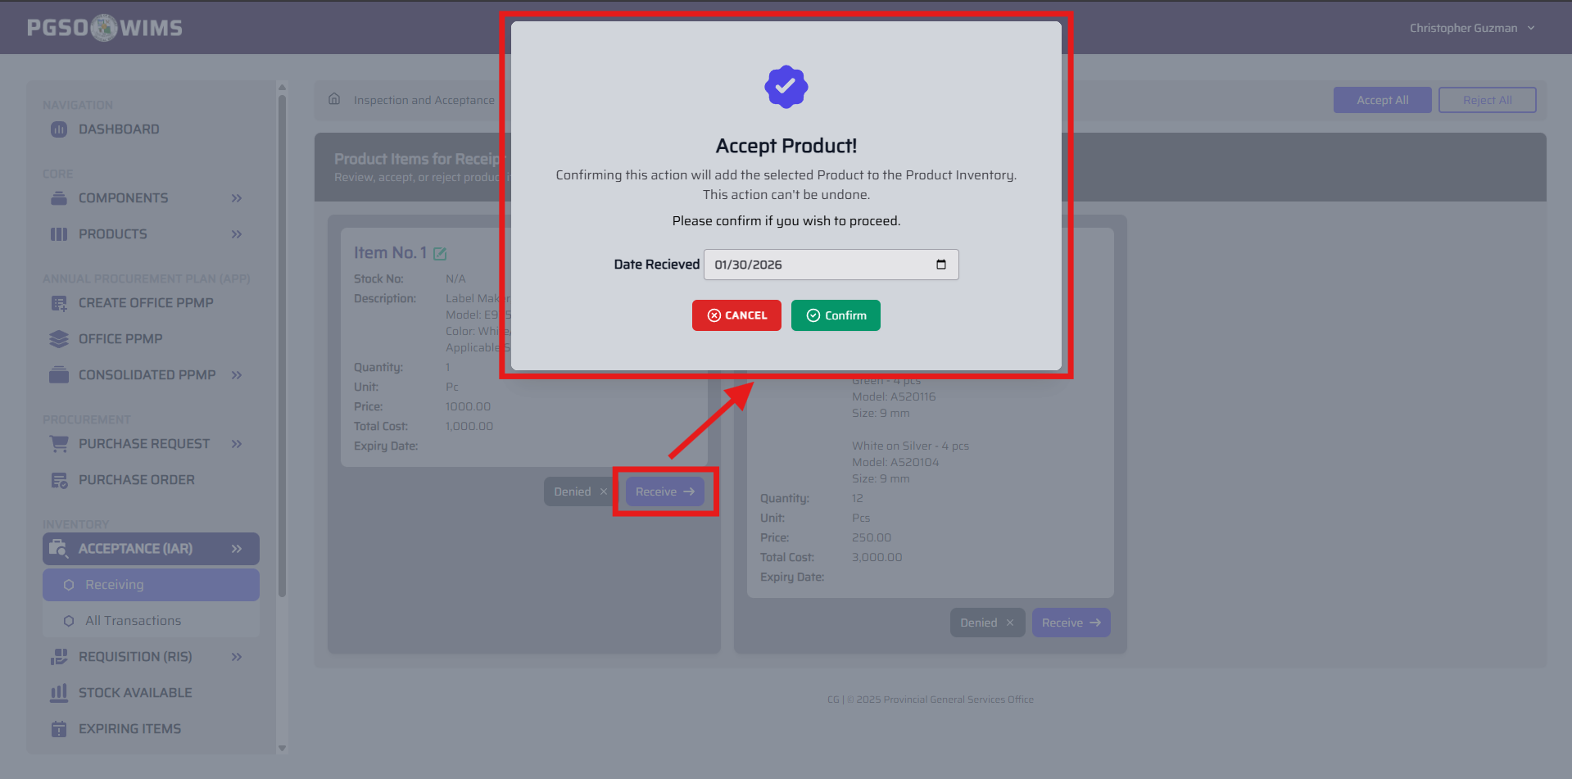
Accept each particular individually.

➤ Reject Particular within the IAR Transaction
Step 1. On a specific IAR Transaction, click on the Denied button.
Step 3. Click Confirm button to proceed.
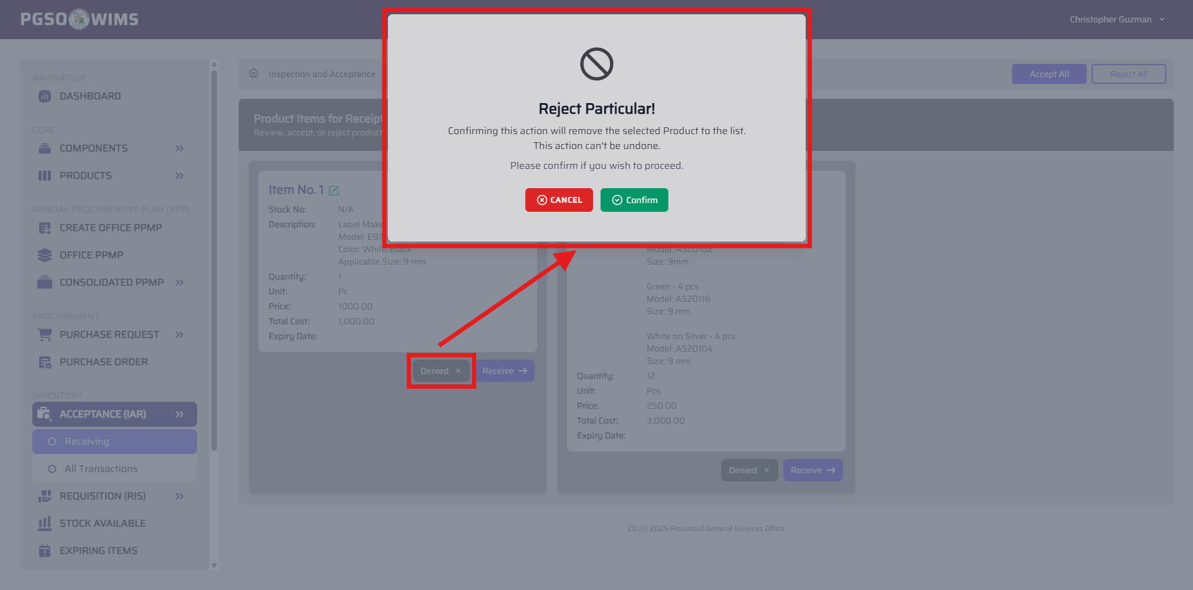
Reject each particular individually.

➤ View All IAR Transaction (Processed)
➡️ This feature shows all the processed IAR Transactions.
Navigate the Page to Acceptance (IAR) → All Transactions 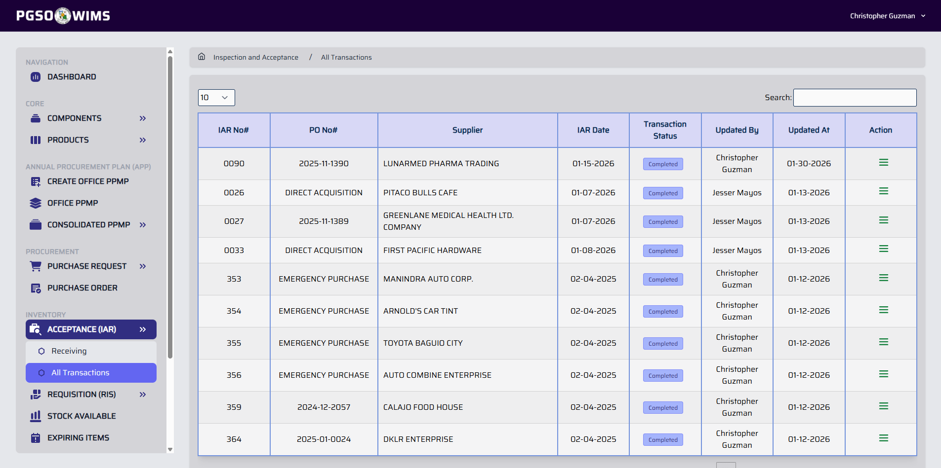

➤ View Processed IAR Transaction
Step 1. On IAR Transaction table, click on the View Icon button.
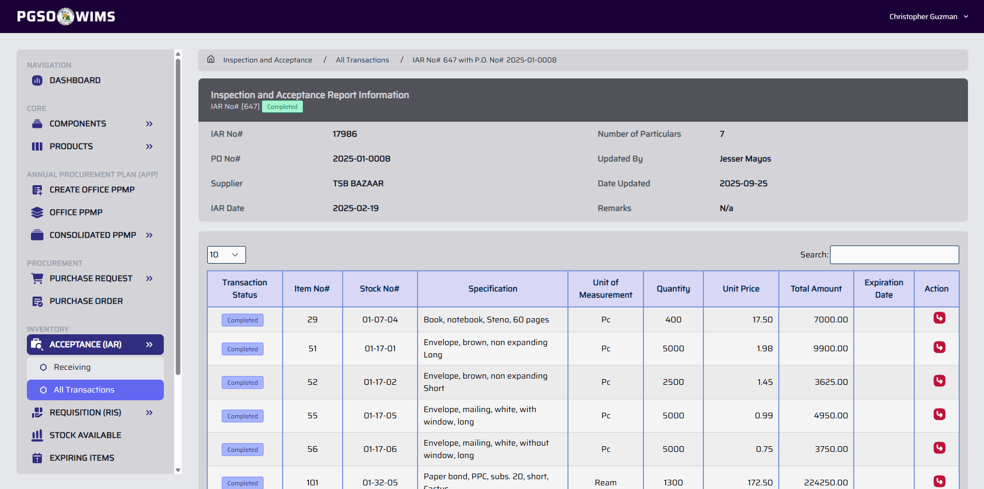 This shows a summary overview of the IAR transaction, including all particulars and their respective statuses.

➤ Return or Recall IAR Particular
➡️ This feature returns the IAR particular to the pending status.
Step 1. On IAR Particular table, click on the Return Icon button.
Step 2. Click Confirm button to proceed.
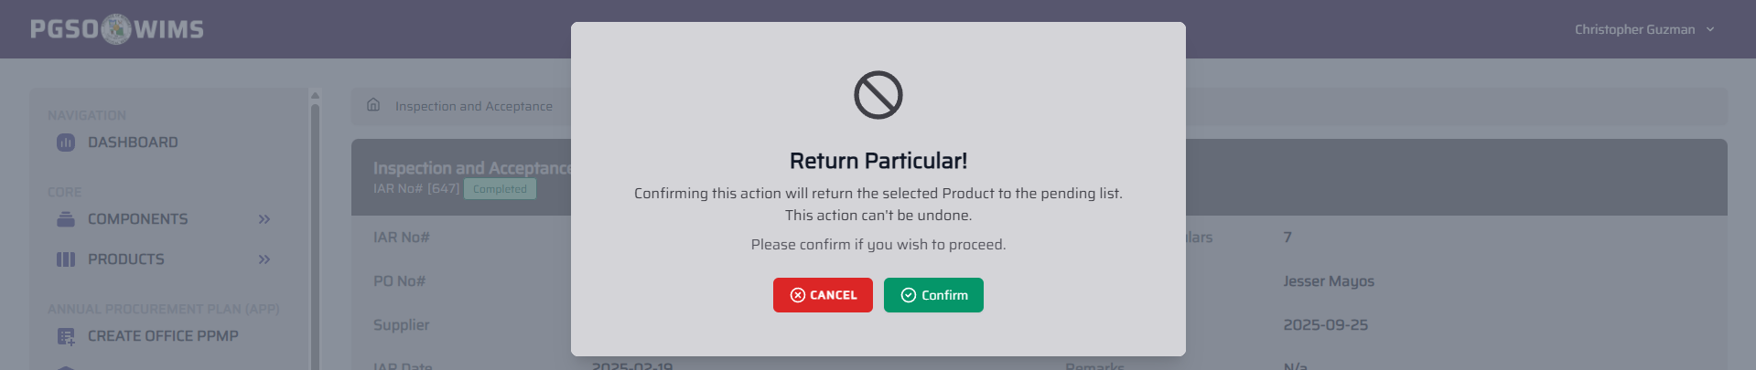

④ REQUISITION AND ISSUANCES SLIP
➡️ This module handles the issuance of items.
Navigate the Page to Requisition (RIS) → Releasing
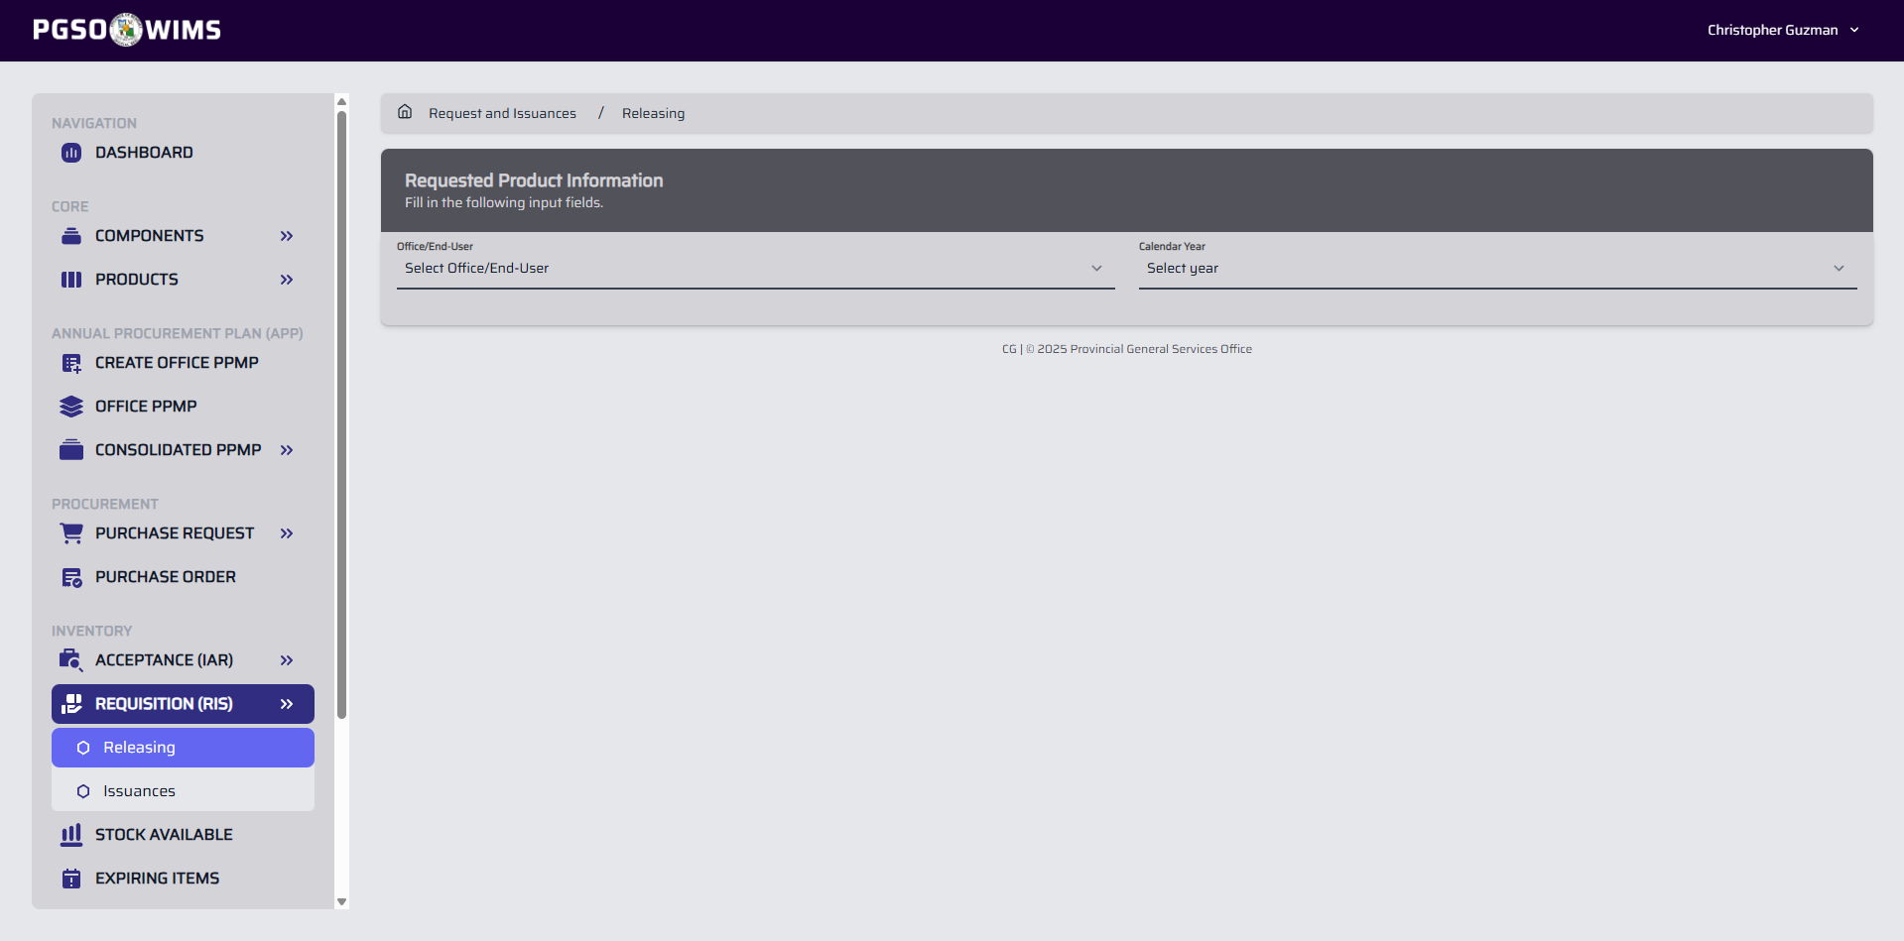

➤ Create RIS Transaction
Step 1. On Releasing Section, provide the needed information on Office (Requestee) and Calendar Year (PPMP Year)
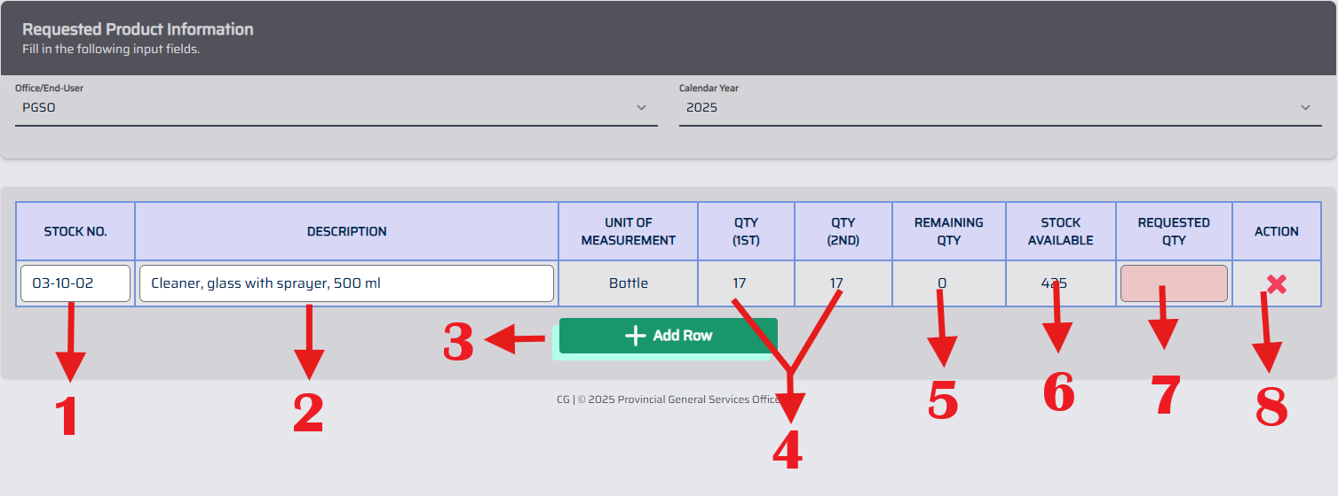
- Search for an item using the Item Code.
- Search for an item using the Description or any keyword.
- Add a new row to the table.
- Display the Quantity Requested in the submitted PPMP.
- Show the Remaining Quantity to be issued.
- Display the warehouse’s current On-hand Stock for the item.
- Enter the Requested Quantity. (Disabled if the field has a red background.)
- Remove a row from the table.
Step 2. Enter all the requested items listed, referring to the above image and description for guidance.
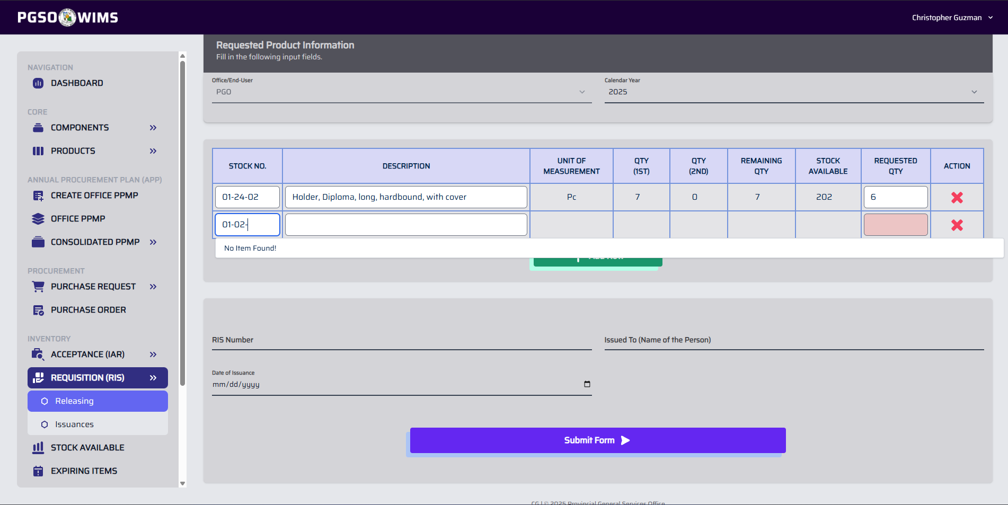
Requested items come from the submitted and approved office PPMP. Items not in the PPMP may return “No Item Found”.
Step 3. Complete the input fields.
Input Fields:
RIS Number – Transaction Code
Issued To – Name of the Receiver
Date of Issuance - Exact date the items were issued
Step 4. Click Submit Form to proceed.
Additional information: Items not listed in the PPMP may still be requested, provided that they are currently in stock. To request such items, select “Other” under Office/End-User, then enter the requested item. Please indicate the requesting office in the Remarks/Description field for reference. (Refer to the image below for a sample transaction)
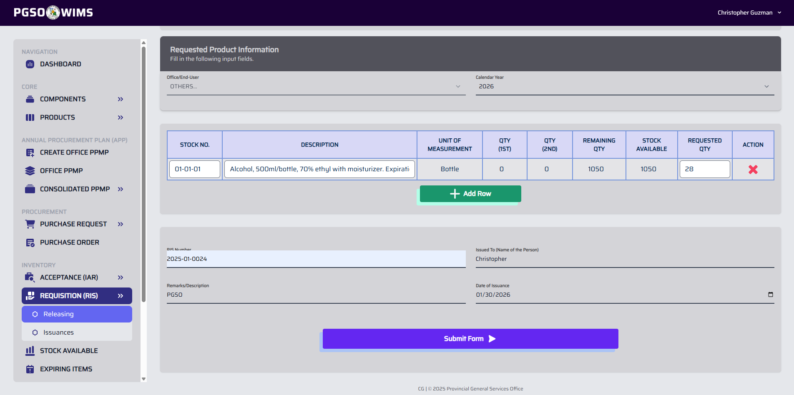
➤ View All RIS Transaction
➡️ This section displays all item issuances by RIS Number.
Navigate the Page to Requisition (RIS) → Issuances 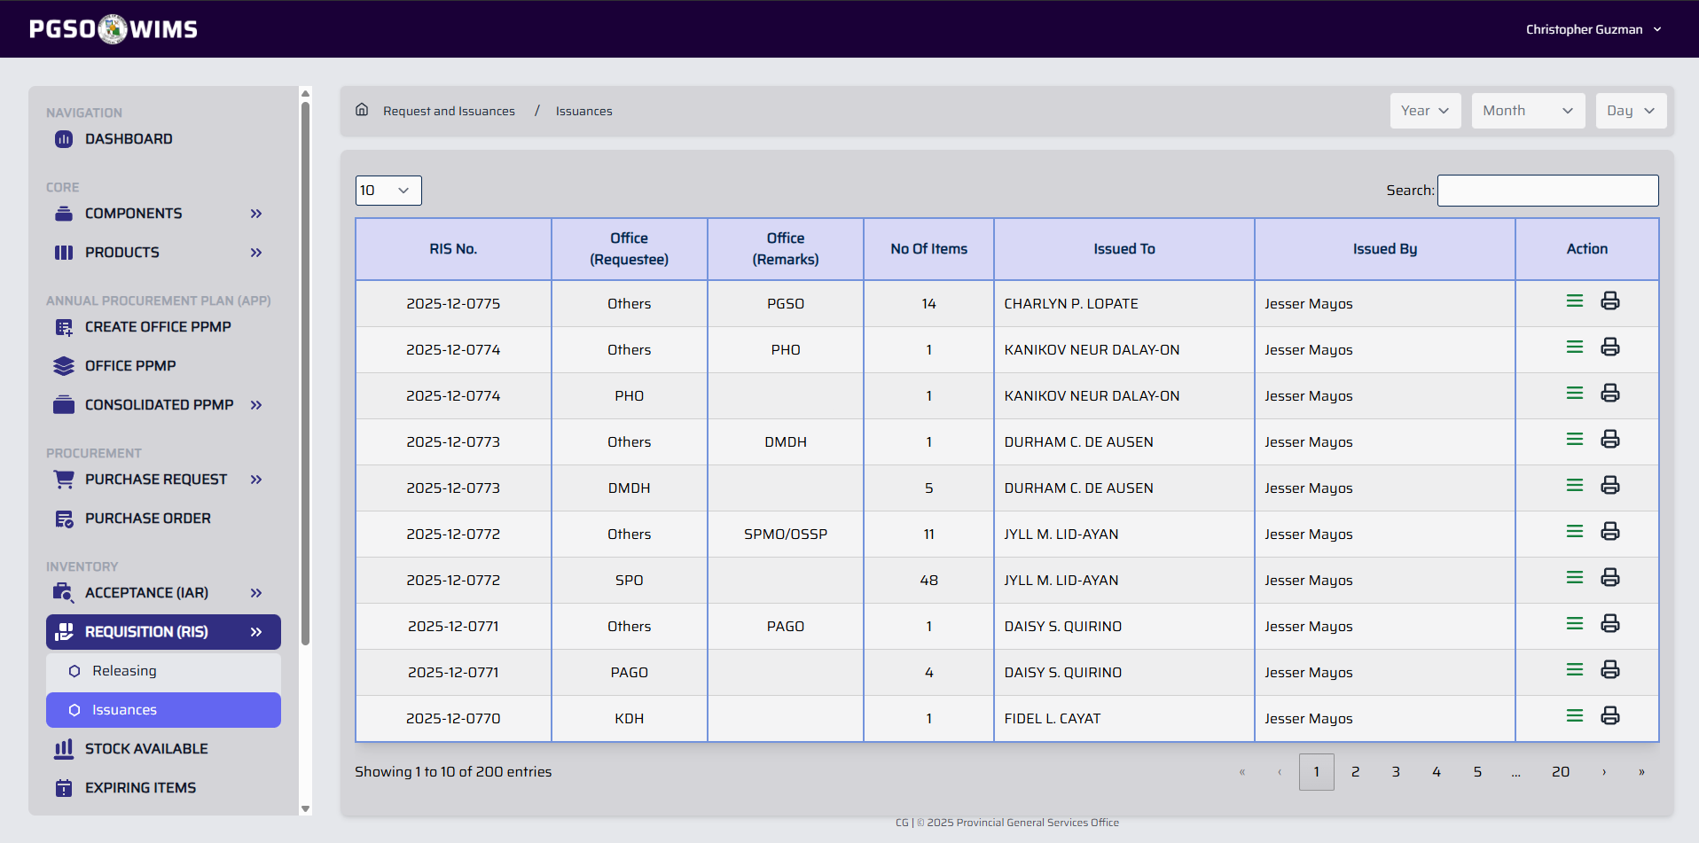
Filter the transactions by Year, Month, Day.

➤ Print RIS Transaction
Step 1. On the transaction table, click on the Print Icon button. This will generate a downloadable copy of the transaction with its requested items.

➤ View RIS Transaction
Step 1. On the transaction table, click on the View Icon button.
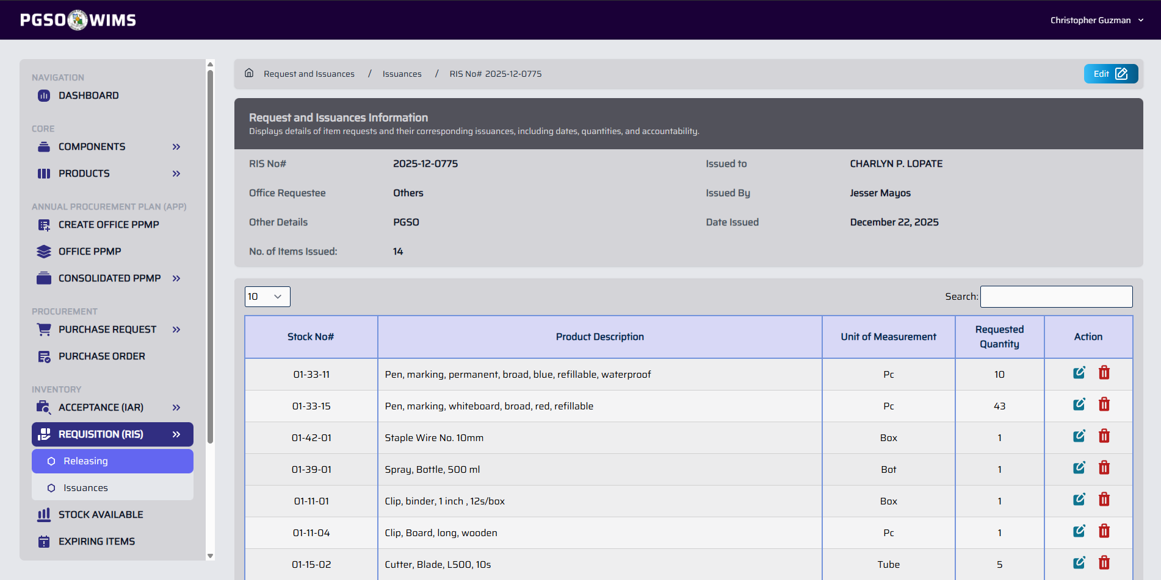
➤ Edit/Update RIS Transaction
Step 1. On the RIS Transaction, click on the Edit button to display a form.
Step 2. Edit the data.
Step 3. Click Confirm button to proceed.
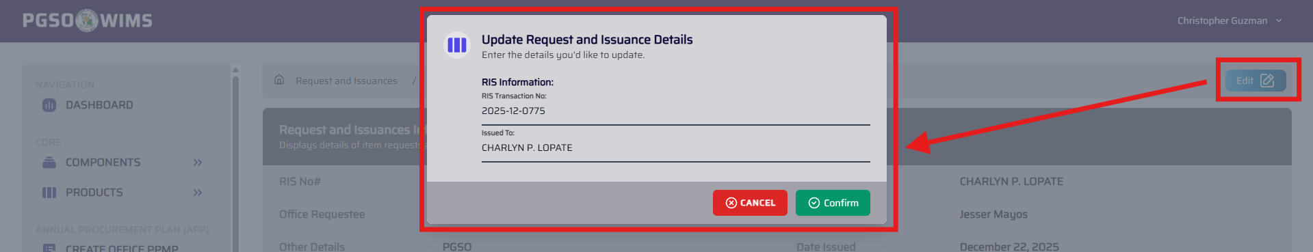

➤ Edit/Update Particular’s Quantity on RIS Transaction
Step 1. On the RIS Transaction’s Particulars table, click on the Edit Icon button to display a form.
Step 2. Edit the quantity.
Step 3. Click Confirm button to proceed.
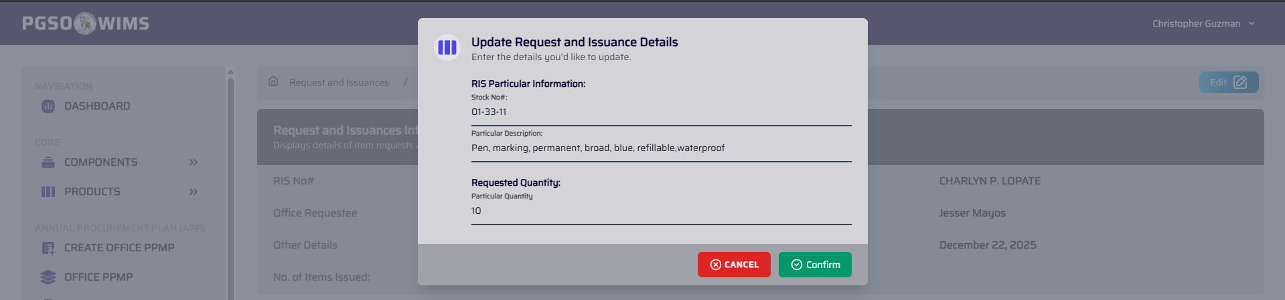

➤ Delete Particular on RIS Transaction
Step 1. On the RIS Transaction’s Particulars table, click on the Trash Icon button to display a confirmation.
Step 2. Click Confirm button to proceed.
